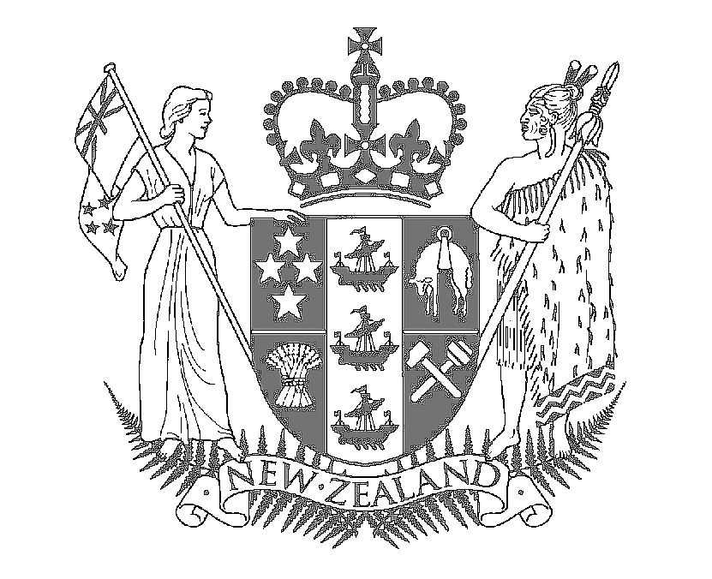

Speech Notes

HON MAHARA OKEROA
Associate Minister for Arts, Culture and Heritage
MP for Te Tai Tonga

Friday 2nd March 2007

Firstly I wish to acknowledge
- Sandy Kaa / Samuga Vili
- Artist – Raphael Stowers
- Kaumatua/Kuia/Elders
- Ngai Tahu (Mark Solomon)
- Maata Waka
- Rob Davison, Chair ACTIS
- Councillor Anna Crigton
- Aranui Community

E nga mana, e nga reo e nga waka of nga hau e wha

I am honored to be asked to speak at the unveiling of UNIFICATION – a community artwork that symbolises and celebrates the diverse cultural makeup that is Aranui.

Aranui has a lot to be proud of. In December last year I attended 5AFFIRM, the 5th Aranui Family Festival a festival, which showcases Aranui’s strengths and unique character. Overall, 5AFFirm left a lasting impression with me

I believe Arts, Culture and Heritage is a dimension of human experience that transcends the diversities of human existence, be it ethnicity, culture, language, customs and values

Today, we join together to celebrate the unveiling of UNIFICATION. To me, UNIFICATION epitomizes Aranui’s sense of cultural wellbeing and identity.

Clearly culture is important to all of us, and community leadership – with local and central government working together – is important to culture.

I am convinced that through the leadership shown in our local communities, like Aranui, we as New Zealanders are able to take pride in who and what we are.

In closing I would like to take the opportunity to acknowledge those groups/individuals involved in bringing about this local artwork
- the Artist – Raphael Stowers;
- Elders – Sandy Kaa and Samuga Vili;
- ACTIS Trust – chair - Rob Davison, Rachel Fonotia and the whanau at ACTIS;
- the Funders - Chch City Council, City Care; and
- elders/whanau/families from the ARANUI community

